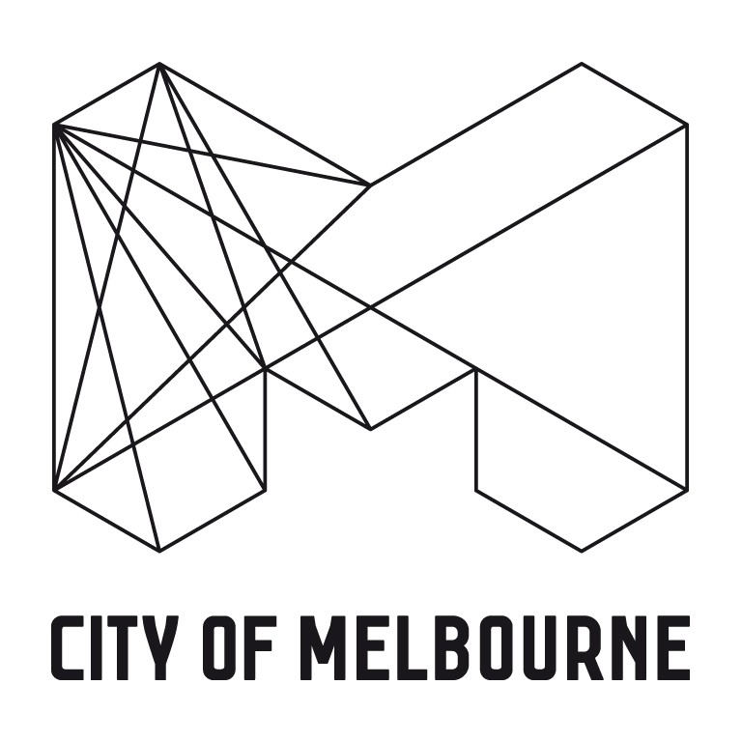

PLANNING PERMIT OBJECTION FORM

Planning and Environment Act 1987

Important notes about the objection to permit application
Is this form for me? This is the form to object to a planning permit application where the City of Melbourne is the decision maker. Please do not use this form to object to Ministerial applications.
- Your objection and the personal information on this form is collected by the City of Melbourne for the purposes of the planning process, as set out in the Planning and Environment Act 1987 (the Act). If you do not provide your name and address, the City of Melbourne will not be able to consider your objection.
- Your objection will be available at the City of Melbourne office for any person to inspect, during the relevant period set out in the Act. A full copy of your objection (including your name and personal information) will be made available on request to any person, for a limited period.
- A summary of your objection will be included in a publicly available planning report, which may be published on Council’s website. Your name will not be published in the planning report. Your objection, and the personal information supplied with it, will not be disclosed to any other external party, unless required or authorised by law.
- You must not submit any personal information or copyright material of third parties without their informed consent. By submitting the material, you agree that the use of the material as detailed above does not breach any third party’s right to privacy and copyright. You can request access to your personal information by contacting the City of Melbourne.
See also Objecting to a planning application

Who is objecting?

Name | Carlton Residents Association Inc. | Contact No. | 0418 351 968
Postal Address | PO Box 1140, Carlton | Post Code | 3053
Email | planningcra@gmail.com

What Planning Permit Application are you objecting to?
Address | 66 Palmerston Street, Carlton | Application No. | TP-2018-510

What are the reasons for your objection?
The Carlton Residents Association advocates on behalf of its members to:
- Support the retention of the heritage assets within Carlton and to discourage new development that fails to respect these assets
- Maintain the quality of the public realm with a focus upon maintaining access to sunlight and sky views,
- and a pedestrian friendly scale.
- Interpret and apply the performance based provisions of the Melbourne Planning Scheme fairly so that the
- interests of no one party are unfairly privileged over the interests of another party.

Issues relating to TP-2018-510:
- Of primary concern is the potential impact of the proposed development on the Canning and Palmerston Street Reserve immediately east of the site
- The application includes no mention of, or diagrams showing, additional overshadowing of this reserve. We suggest that this should be a matter for consideration under policy at 22.2 Sunlight to Public Spaces for under the heading of "Other Public Spaces within the municipality".
- We also note that, by virtue of its location next to the reserve, the eastern elevation of the proposed development will be very prominent when viewed from Canning and Palmerston Streets. It is difficult to assess the qualities of this elevation based on the quality of the drawings and information provided. The elevation is shown in black and white lower drawing on sheet Pl 01 06). A colour render of this elevation, at the very least, would assist us in reviewing this aspect of the proposal. Three-dimensional renders would be preferable."The use of different materials on each building element as a strategy to 'break up' the volume of the building is supported.
- The reinstatement of existing side wall, in the same profile, is also supported.
Carlton Residents Association Inc. 14 October 2018
(If there is not enough room, attach a separate page)

How to Apply and Enquiries:
Mail: Planning Department - City of Melbourne  GPO Box 1603 Melbourne 3001 | Email: planning@melbourne.vic.gov.au | Tel: 03 9658 9658

