
PLANNING PERMIT OBJECTION FORM
Planning and Environment Act 1987

Important notes about the objection to permit application
Is this form for me? This is the form to object to a planning permit application where the City of Melbourne is the decision maker. Please do not use this form to object to Ministerial applications.
- Your objection and the personal information on this form is collected by the City of Melbourne for the purposes of the planning process, as set out in the Planning and Environment Act 1987 (the Act). If you do not provide your name and address, the City of Melbourne will not be able to consider your objection.
- Your objection will be available at the City of Melbourne office for any person to inspect, during the relevant period set out in the Act. A full copy of your objection (including your name and personal information) will be made available on request to any person, for a limited period.
- A summary of your objection will be included in a publicly available planning report, which may be published on Council’s website. Your name will not be published in the planning report. Your objection, and the personal information supplied with it, will not be disclosed to any other external party, unless required or authorised by law.
- You must not submit any personal information or copyright material of third parties without their informed consent. By submitting the material, you agree that the use of the material as detailed above does not breach any third party’s right to privacy and copyright. You can request access to your personal information by contacting the City of Melbourne.
See also Objecting to a planning application

Who is objecting?

Name | Carlton Residents Association Inc. | Contact No. | 0418 351 968
Postal Address | PO Box 1140, Carlton | Post Code | 3053
Email | planningcra@gmail.com

What Planning Permit Application are you objecting to?
Address | 19 Owen Street, Carlton | Application No. | TP-2018-228

What are the reasons for your objection?
The Carlton Residents Association advocates on behalf of its members to:
Support the retention of the heritage assets within Carlton and to discourage new development that fails to respect these assets\ Maintain the quality of the public realm with a focus upon maintaining access to sunlight and sky views,
and a pedestrian friendly scale.
Interpret and apply the performance based provisions of the Melbourne Planning Scheme fairly so that the
interests of no one party are unfairly privileged over the interests of another party.

The Carlton Residents Association is generally supportive of this application, however the Association submits the following comments for your consideration.

The property forms part of the the streetscape around Murchison Square, which is listed in the Victorian Heritage Database as an item of State Significance. Many nearby properties on Owen Street are also listed in the City of Melbourne's Heritage Places Inventory (June 2016): 11 properties (21, 23, 25, 27, 29, 35, 37, 41, 45, 47 and 49 Owen Street) are listed as having a streetscape grading of 1 (being the highest grade) and buildings gradings of B and C (A being the highest). These designations suggest the built form and streetscape character are of particular significance and an appropriate response from any new developments is therefore warranted.

These properties - and others around Murchison Square - generally feature narrow verandas and in some cases narrow gardens, low fencing that has a degree of transparency, and widows overlooking the street. This arrangement is also achieved by the more modern apartment building to the east at 1 Owen Street. There are three identifiable exceptions to this pattern on the southern side of Owen Street: two instances where part of the dwelling is built up on the front site boundary (at 33 and 37 Owen) and the garage that is the rear of 12-14 Carlton Street. The latter could be redeveloped in future and should not be viewed as a permanent feature.

In this context the proposal to include a metal clad bin enclosure of 3 metres in height and a similar bike enclosure (1.5m in height) at 19 Owen Street would result in an inappropriate edge condition. A more conventional interface, taking clues from the adjoining properties, that results in a softer interface and natural surveillance of the street, would be preferable in this location.
Carlton Residents Association Inc. 09 July 2018

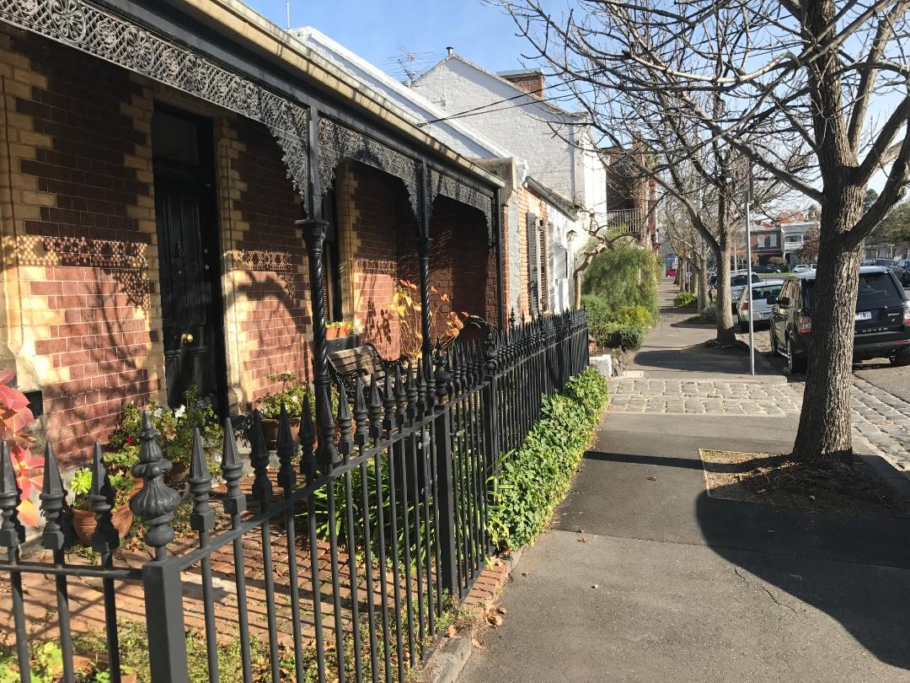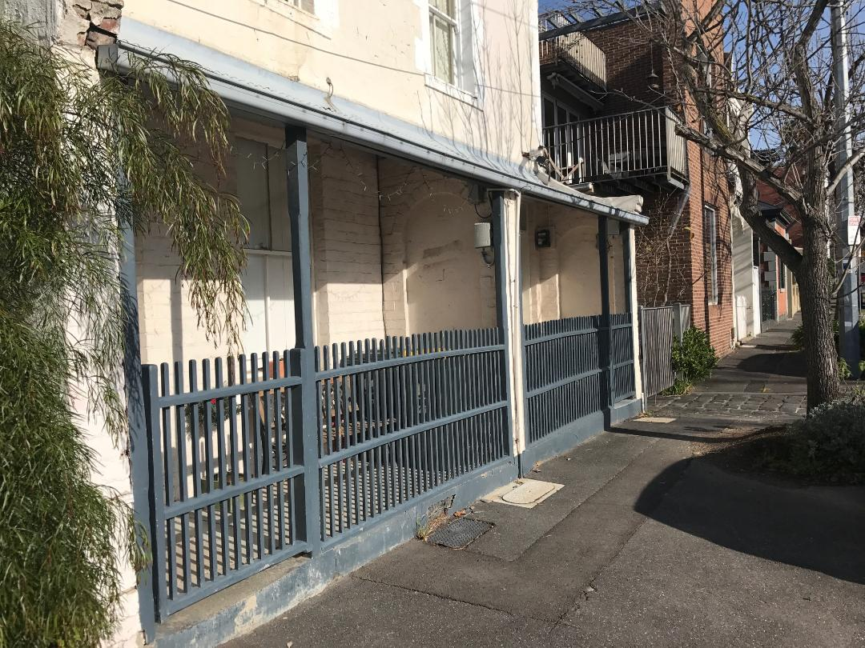
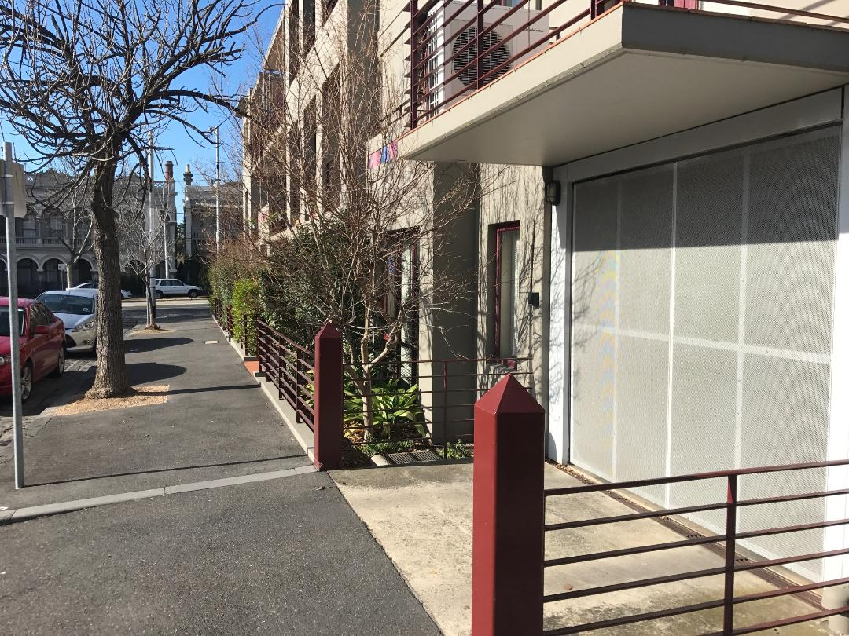

(If there is not enough room, attach a separate page)

How to Apply and Enquiries:
Mail: Planning Department - City of Melbourne  GPO Box 1603 Melbourne 3001 | Email: planning@melbourne.vic.gov.au | Tel: 03 9658 9658

