Researching the history of your house
Key questions to ask
- When was it built?
- Who designed/built it?
- Who has lived there?
- What changes have been made?
- What was there before it was a house?
- Has the street numbering changed?
Recording your findings
- Take notes as you go
- Record references, copy links
You may want to refer back. Things can be harder to find the second time. Noting search terms and copying links may help reduce frustration (e.g. “how did I find that again?”)
- Things change all the time
- Conflicting information is common
Where to look for information
Melbourne Library Service www.melbournelibraryservice.com.au
- Library website – local history
- Sands & McDougall directories (make a booking to use LH computer)
- Vertical files (by appointment)
- Online heritage collection (via library catalogue)

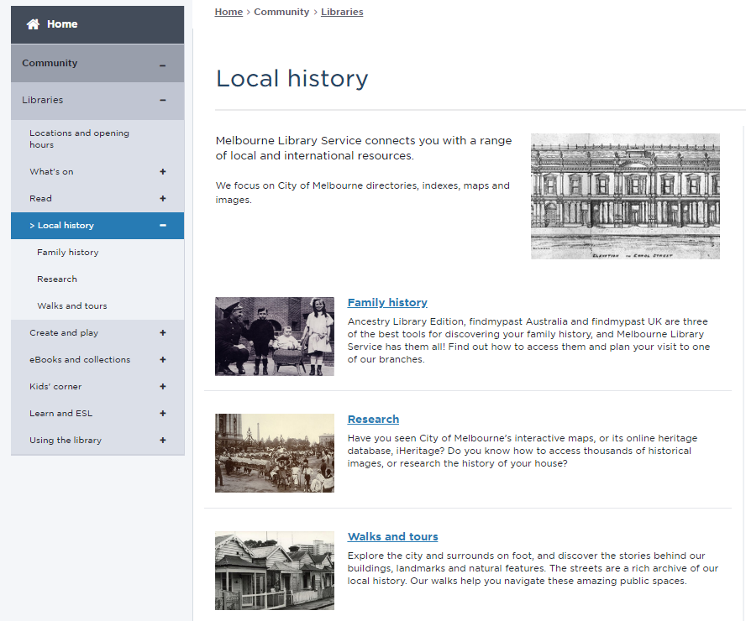

Where to look for information (cont.)
City of Melbourne www.melbourne.vic.gov.au
- i-Heritage database (access via library website)
- Maps http://maps.melbourne.vic.gov.au
- Planning permit register (under Building and Development)

State Library of Victoria www.slv.vic.gov.au
- MMBW maps
- Images

Public Records Office Victoria www.prov.vic.gov.au
- Rates & valuations (including City of Melbourne rate books)
- Plans & permits
- Research guides (e.g. Historic Homes, download for free https://www.prov.vic.gov.au/explore-collection/historic-homes)

State Government Victoria www.vic.gov.au
- Melbourne Planning Scheme http://planningschemes.dpcd.vic.gov.au/schemes/melbourne
- Landata https://www.landata.vic.gov.au

Heritage Council of Victoria
- Victorian Heritage Database http://vhd.heritagecouncil.vic.gov.au

Trove (National Library Australia) http://trove.nla.gov.au
- Digitised newspapers
- Images

Local historical societies
- May have information depending on what they collect
- Societies in the City of Melbourne listed on library website

