VICTORIAN CIVIL AND ADMINISTRATIVE TRIBUNAL
PLANNING AND ENVIRONMENT DIVISION
planning and environment LIST | vcat reference No. P1497/2018  Permit Application no. TP-2018-59
CATCHWORDS
Demolition, alterations and additions to a heritage significant building; Neighbourhood character; Amenity impacts to neighbours; Car parking provision; Use of rear laneway.

APPLICANT | Mr J Piccolo
responsible authority | Melbourne City Council
RESPONDENTs | Ms C Bernard & others, Mr T Redmond & Ms P Sumithran and Ms M Marasco & others
SUBJECT LAND | 6-10 MacArthur Place North, Carlton
WHERE HELD | Melbourne
BEFORE | Rachel Naylor, Senior Member
HEARING TYPE | Hearing
DATEs OF HEARING | 7 & 8 March and 21 May 2019
DATE OF ORDER | 11 September 2019
CITATION | Piccolo v Melbourne CC [2019] VCAT 1404

Order

No permit granted
- In application P1497/2018 the decision of the responsible authority is affirmed.
- In planning permit application TP-2018-59 no permit is granted.

Rachel Naylor
Senior Member

Appearances
For Mr J Piccolo (the Applicant) | Mr J Cicero, solicitor of Best Hooper  He called the following expert witnesses:  - Mr V Gnanakone, traffic engineer of One Mile Grid; and  - Mr B Raworth, heritage consultant of Bryce Raworth Pty Ltd
For Melbourne City Council (the Council) | Mr D Song, town planner of SongBowden Planning Pty Ltd
For Ms C Bernard and others (Ms Bernard) | Ms C Bernard
For Mr T Redmond & Ms P Sumithran (Mr Redmond) | Mr P Barber, town planner of Urban Edge Consultants Pty Ltd
For Ms M Marasco & others (Ms Marasco) | Mr R Hocking, town planner of CityShire Planning Pty Ltd

Information
Land description | The site comprises Nos. 6, 8 and 10 on the north side of MacArthur Place North in Carlton. The MacArthur Place North frontage is 11.66 metres, the maximum depth is 26.5 metres and the site area is 294 square metres. The site has a partial rear abuttal to Nicholls Lane. The land falls from west to east. The site is occupied by three attached two storey terrace houses. They have the appearance of a single building. There is a courtyard area at the rear of each terrace house.
Description of proposal | Demolition, alterations and additions to the existing building including a third storey. These modifications will reconfigure the existing three terraces into three 3 bedroom apartments, one on each floor level.  The extent of demolition is the rear portion of the buildings, beginning approximately 7.7 metres behind the front façade.  Two basement levels are also proposed that will provide car parking for six cars (two spaces per dwelling) via a car lift that is accessed from the rear via Nicholls Lane.
Nature of proceeding | Application under section 77 of the Planning and Environment Act 1987 – to review the refusal to grant a permit.
Planning scheme | Melbourne Planning Scheme
Zone and overlays | General Residential Zone Schedule 1 (GRZ1)  Heritage Overlay Schedule 1 – Carlton Precinct (HO1)  Parking Overlay Schedule 12 (PO12)
Permit requirements | Clause 32.08-6 To construct two or more dwellings on a lot in GRZ1  Clause 43.01-1 Demolition, construction of a building, and construction and carrying out of works in HO1  Clause 52.06-3 Provision of car parking in excess of the maximum rate of one car space per dwelling specified in PO12

Reasons

What is this proceeding about?
- Mr Piccolo seeks planning permission to undertake demolition, alterations and additions (including a three storey rear addition) to the land known as Nos. 6-10 MacArthur Place North in Carlton.
- Nearby property owners oppose this proposal because of the use of the rear laneway (Nicholls Lane), the impacts on the amenity of nearby residential properties and the unacceptable design response to the neighbourhood character and the significance of the Carlton heritage precinct.
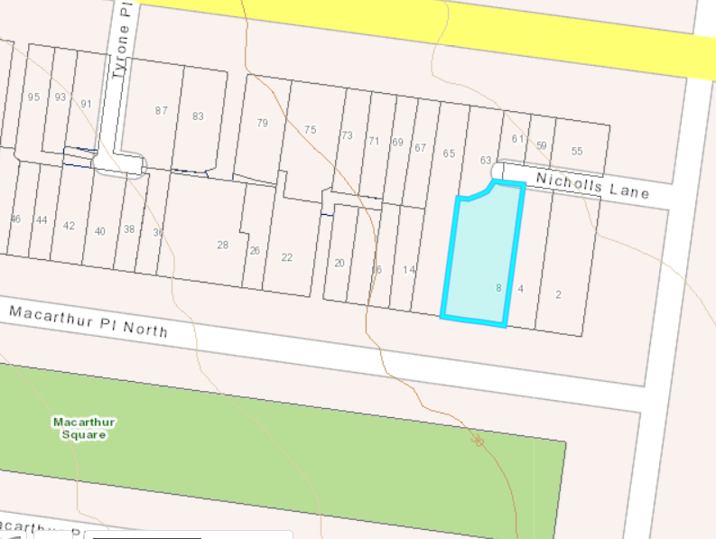

Location of site and surrounding properties including Elgin Street properties and Nicholls Lane
- The Council shares the concerns that the proposal is unacceptable in terms of its response to the heritage significance, neighbourhood character and residential amenity.
- Having considered the relevant planning considerations and the submissions and evidence presented, I have decided that this proposal is not an acceptable design response to its interfaces, the neighbourhood character or the significance of the heritage place. The reasons why I have reached this decision are explained below.

demolition
- There is no separate demolition plan(s) in either the permit application plans or the substituted amended plans. There is an existing conditions plan in the permit application plans. The walls and the chimneys to be retained/removed are shown in the substituted amended plans. The Level 2 plan contains a notation that the existing galvanised corrugated iron roofing will be replaced with ‘new roofing to match’.
- Ms Gould acknowledges that there are no internal heritage controls applying to this site, so demolition of internal walls, floors, etc requires no planning permission. At present, Nos. 6, 8 and 10 each contain a separate dwelling with party walls separating them, and they each have separate rear courtyard spaces.
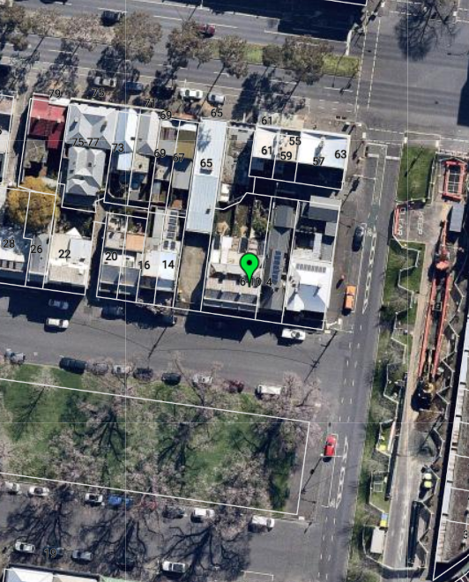

The chimneys
- Ms Gould considers all six of the chimneys should be retained rather than the front three and the northeast rear chimney (closest to No. 4 MacArthur Place North). I agree with her that they are all visible to varying degrees within MacArthur Square. The Applicant submits that this visibility is not the relevant consideration in the planning scheme. I agree that the Heritage local planning policy anticipates a typical street scenario whereby the visibility is measured from the footpath on the opposite side of the street. In this case, MacArthur Square is opposite. Its grassed areas are slightly raised above the adjacent roads and it is a long park enabling quite expansive views of the buildings along the adjacent roads. In this reasonably unique setting, I agree with Ms Gould that the chimneys should be retained. During the break between the second and third hearing days, the Applicant circulated further revisions to the substituted amended plans (some of which was with my leave in my Interim Order). The Applicant’s covering letter states these revisions (‘the 1 April Plans’) allow for the retention of all existing chimneys. Whilst Mr Raworth supports the removal of two of the chimneys, he orally advised he was happy for all of them to be retained. I support all of the chimneys being retained.

The external rear north wall and windows
- Ms Gould considers the rear north wall and first floor windows of the three dwellings appear to be of late 1860s construction and intact, so they should be retained.
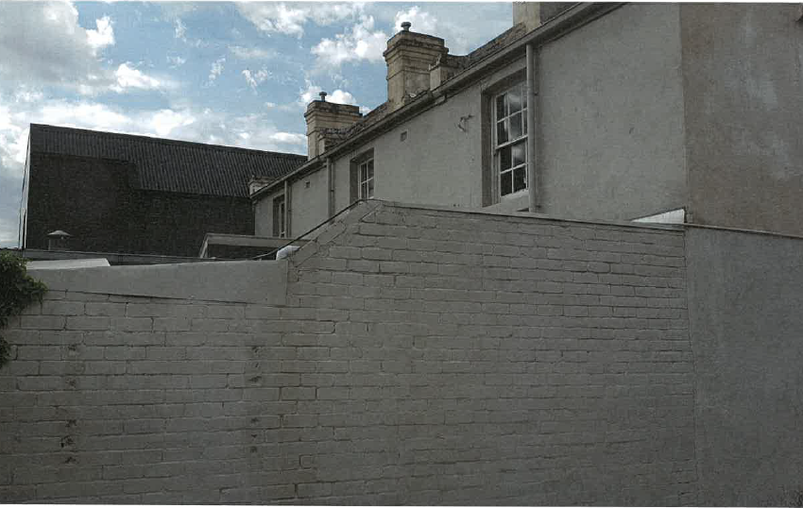
- Mr Raworth disagrees as he considers the north wall makes no contribution to the significance, character or appearance of the streetscape. This rear view (as shown above from the Council’s photographs, taken on the vacant property next door) has limited visibility and certainly no significance in the surrounding street network, including from Nicholls Lane given its substantial setback. This rear elevation is effectively the rear of the two room depth of the first floors, which Ms Gould identified as the preferred extent of retention in the Heritage local policy. Retaining this elevation would presumably necessitate a gap being created between the old fabric and any new fabric. In a circumstances where this north wall makes no contribution to the heritage significance of the surrounding streetscapes now, I am not persuaded its retention is preferable.

The front façade
- Ms Gould identified that the substituted amended plans show one floor level across the entire frontage of the existing three dwellings. Given the slope of the land, this means the eastern end would have an elevated floor level sitting behind the windows and doors in the front elevation. Ms Gould also identified that the plans appear to show a wider ground floor doorway at the west end, which presumably means the loss of the existing door and doorway. She considers this should be retained.
- Mr Raworth considers the internal reconfiguration and a single point of disabled access at the ground level are acceptable changes to the front façade. He acknowledges that what is lacking is the detailing of all of the elements in the front façade, including the wing walls. Ms Gould describes the proposal as relatively simple at the front, which she says is good. I accept that limited changes to the front façade, such as to one entry door are reasonable and will not adversely affect the heritage significance of this precinct. The existing building is distinctly lacking in heritage detailing at the moment, so the development of this site creates the opportunity to enhance its streetscape presentation and its contribution to the significance of the heritage place.

alterations and additions
- There is some overlap in the consideration of the merits of the proposed alterations and additions in regard to neighbourhood character and heritage considerations. The entirety of the immediately surrounding area is contained within the Carlton heritage precinct, hence the significance of this precinct and the contribution that this site makes is of greater influence on the merits of the detail of the design of this proposal than neighbourhood character that focuses more simply upon new development fitting in to a neighbourhood.
- The intensity of urban consolidation and change anticipated for a neighbourhood is derived from the relevant State and local planning policies in the planning scheme. I agree with the Applicant that the local planning policy framework in this planning scheme actually provides minimal guidance for ‘stable residential areas’. The planning scheme says these areas will continue to experience ‘limited change such as in-fill development and alterations and additions’, with new development that ‘fits in with the existing valued character’. Infill development could include new additions up to 11 metres in height because that is what the General Residential Zone Schedule 1 allows in this case. The height of the proposed additions has been clarified in the Applicant’s 1 April Plans and demonstrates that the maximum permissible building height is met. However, just because a maximum building height is specified does not mean a proposal can automatically build to that height. A key question from a neighbourhood character perspective is whether this proposal ‘fits in with the existing valued character’, which is strongly influenced by the fact that the neighbourhood is recognised as having heritage significance.
- Ms Gould considers the additions are bulky and intrusive in the streetscape with the visibility dominating MacArthur Place North and South and MacArthur Square. She also considers the development will be visible from Canning Street (to the east) and have a bulk that is inconsistent with the character of that streetscape. The Council and the surrounding neighbours share these concerns.
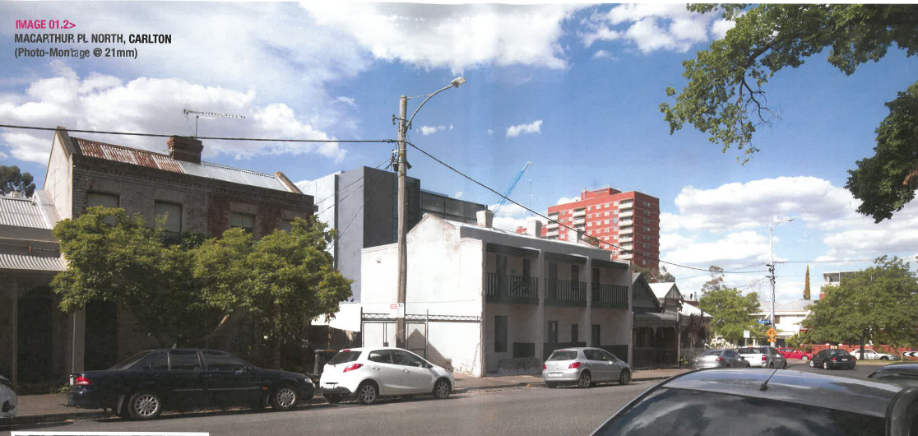

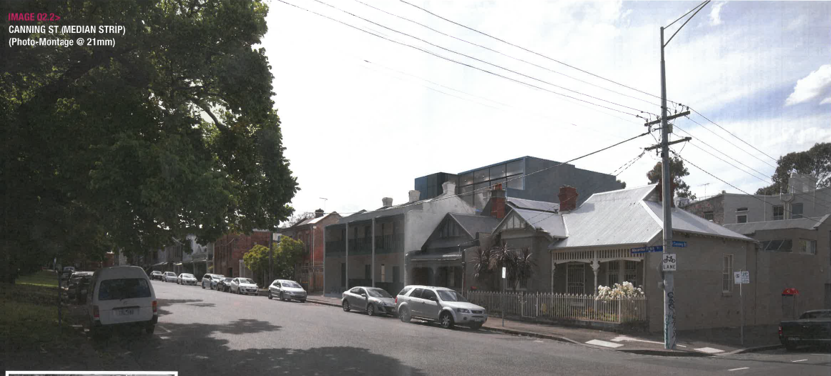
- Mr Raworth acknowledges that this site has a fair degree of visibility because of the vacant land next door to the west (used for car parking), MacArthur Square and the wide streets of both MacArthur Place North and Canning Street. The Heritage local planning policy seeks partial concealment, which Mr Raworth considers is substantially achieved and the three storey addition does not have a fundamental adverse impact. He does not consider oblique views (such as the Canning Street photomontage extract on the previous page) are what is meant to be considered.
- The physical circumstances of this site’s context means it has increased visibility. I agree with Mr Raworth that that of itself should not mean the site cannot be developed with rear additions. The Heritage policy provides guidance about what could be considered to be an acceptable design response that will not adversely affect the heritage significance. However, the policy is generic and a guideline. As I have already stated, the actual physical context also needs to be considered.
- The Level 2 floor plan nominates that the lift and balcony are set back 9 metres and the glazing to the living areas of apartment 3.1 is set back about 11 metres. The lift element is a dominant and tall feature in form and colour. I do not support this feature. The greater setback of 11 metres with a glazed façade contributes more positively to the achievement of partial concealment.
- The upper floor (Level 2) is built from one side boundary to the other, and the architectural appearance is a solid form that is box-like with solid walls lacking in any articulation. Level 2 is of a form and appearance that is quite visible in oblique views, still within the same heritage precinct. I agree with the Council and the neighbours that its presentation detracts from the heritage significance.
- Returning to neighbourhood character, the planning scheme seeks infill development that fits in to the valued characteristics. I am not persuaded that the proposed upper level, in particular, fits in with the scale and form of surrounding buildings, which are part of the characteristics of the neighbourhood.

Amenity impacts
- The neighbours at Nos. 2 and 4 MacArthur Place North are concerned about the visual bulk and the extent of shadow that will be cast across their respective courtyards. No. 4 has recently completed alterations and additions to the house, including the rear courtyard. The plans of these building works and the photographs tabled of No. 4’s finished levels of the rear courtyard demonstrate that the substituted amended plans have not considered the shadow impact accurately. Between the second and third hearing days, my Interim Order allowed the Applicant the opportunity to prepare and circulate revised shadow diagrams.
- The 1 April Plans illustrate that the new shadow cast at 2 and 3pm on the September Equinox will fall within existing shadows cast onto Nos. 4 and 2 MacArthur Place North. However, the Council and the residents point out that this extent of new shadow is as a result of changes to the overall form of the proposed additions, particularly the upper level. I agree that there are quite significant changes to this level in the 1 April Plans. Rather than try and describe them, I have included extracts of the Level 2 plans.
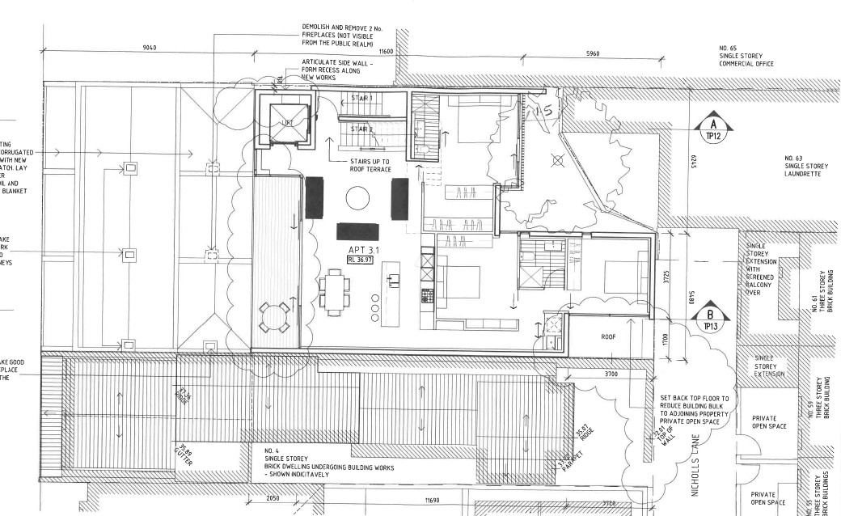

Level 2 Plan of substituted amended plans
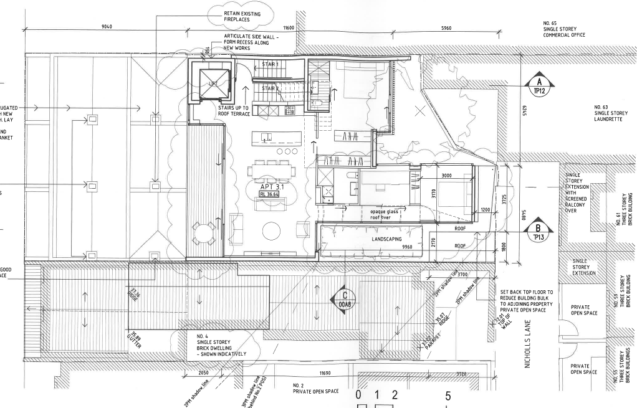

Level 2 Plan of 1 April Plans
- During the discussion at the end of the hearing about permit conditions, No. 4 requested a one metre setback from the east side boundary for the remaining section of apartment 3.1 that is shown built to the boundary in the 1 April Plans. The Applicant agreed this could be done. So, in addition to the array of changes in the 1 April Plans, it appears a further change could also be made. Whilst these changes all assist in improving the amenity impacts of visual bulk and overshadowing to the east, they also need to be considered in terms of neighbourhood character and heritage significance. I am not persuaded that making this extent of design changes ‘on the run’ during a protracted hearing process is an acceptable way in which to properly consider all of the relevant considerations under the planning scheme. I support these changes from an amenity perspective, but I remain concerned about whether these changes sufficiently address the heritage and neighbourhood character built form considerations.

Internal amenity
- The provision of private open space for the ground and first floor apartments is unacceptable.
- The ground floor apartment has a rear north facing courtyard but it is surrounding on all sides by masonry fences or walls. The shadow studies of the proposed building conditions in the substituted amended plans suggest that it will receive limited sunlight throughout the September Equinox hours of 9am to 3pm. Any new design should seek to provide greater areas that can benefit from the northerly aspect without excessive overshadowing.
- The private open space for the first floor apartment comprises the first floor front verandah and an area in the southwest corner that is located behind the front façade and verandah and is roofed. This is a poor design outcome as the private open space has limited natural light and ventilation as well as a poor configuration limiting its useability. Given this apartment has the benefit of a rear northerly orientation, any new design should consider providing an area of north facing private open space.

use of nicholls lane for vehicle access
- Nicholls Lane is a bluestone laneway that extends from Cardigan Street at its eastern end to the northeast rear corner of this site and an abuttal with 63 Elgin Street at its western end. Ms Bernard describes the Lane as 3.5 metres wide, 20 metres long and:
- Three properties use it as their sole access (pedestrian access) to their homes;
- Seven properties use it to store their bins; and
- Three properties have secondary access to it.
- She and other property owners, tenants and business owners along the Lane are concerned about the potential pedestrian safety implications of cars, garbage bins and pedestrians all utilising the laneway. She submits the proposed access arrangements are asking too much of the area and will turn ‘a safe environment into a daily hazard’.
- Nicholls Lane appears to be a little unusual. It is a laneway, which means it is a road and is therefore legally available to provide vehicle access to those properties that have the benefit of a frontage to it. However, the reality of the existing situation is a little different.
- None of the properties currently have vehicle access available;
- A couple of Elgin Street properties have rear pedestrian access doors that enable goods to be loaded/unloaded from the laneway;
- The laneway is dominated by garbage bins, and I was given evidence of permission that the Council has given some properties to store their bins in the laneway; and
- The laneway has a number of pedestrian gates, including at least two that also have street numbers and letter boxes adjacent to the respective gate.
- During the hearing, Ms Bernard identified that the existing situation had not been fully understood and considered by Mr Gnanakone. Hence, between the second and third hearing days, I issued an Interim Order requiring Mr Gnanakone to undertake further swept path analyses that give regard to the existing pedestrian gates and the storage of waste bins in Nicholls Lane. Mr Gnanakone explained this analysis is conservative as he considered the swept paths on the basis of all the waste bins being the larger 240 litre bins, a B99 vehicle and a 100mm separation between each bin within the laneway. His analysis demonstrates the bins and pedestrian entrances do not otherwise impede the laneway operating as a shared pedestrian and vehicular zone. His swept path analyses illustrate the relocation of all of the bins to the south side of the laneway. This raised concern from No. 2 MacArthur Place North, but the location of the bins is not a detail that I need to determine.
- Nicholls Lane is a road that is managed by the Council in its capacity as a road manager. The storage of bins in the laneway is also managed by the Council under its local laws. Hence, activities within the laneway are the subject of Council permissions that are separate to the planning permission being sought here for the development of this site. All I need to be satisfied about is that the laneway can physically accommodate vehicles as well as bins and pedestrian gates. Mr Gnanakone’s further swept path analyses demonstrates that the laneway can do this. Hence, physically, the sharing of the laneway for vehicles, pedestrians and garbage bins can be achieved. Whether it can be achieved technically is a matter to be resolved by the Council and the other affected owners, e.g. if Council permission is necessary and can be obtained to relocate some of the bins.

car parking provision in excess of maximum in parking overlay
- PO12 came into effect in the planning scheme in 2010 as part of Amendment C133, with the Explanatory Report outlining why the amendment was required:
The amendment is required to change the approach to the provision of car parking in some inner city areas from a requirement to provide a minimum number of car parking spaces to the introduction of a car parking limitation policy for residential development. The limitation policy will be pursued through the introduction of a maximum car parking rate for residential development (dwellings) in certain inner city areas where access to public transport is excellent. This would replace the current minimum car parking provision requirements for residential (dwelling) developments in those areas. The amendment seeks to discourage unnecessary reliance on the motor vehicle and encourage more sustainable forms of transport including walking, cycling and public transport.
- The Applicant submits the desire for additional car parking on this site is a personal preference. The provision of three car spaces accords with PO12, so what requires consideration is the proposed additional three spaces. The Council has no concern with the incorporation of additional car parking although there is no evidence that Council undertook an assessment of the acceptability of this proposal against the decision guidelines of PO12.
- Mr Gnanakone’s expert evidence statement does not address the PO12 decision guidelines, so he orally dealt with this during the hearing. He considers the car parking provision is acceptable because:
- The traffic generation will be low;
- There are no relevant planning policies;
- There is no empirical analysis because ABS data does not distinguish large/quality apartments from other apartments;
- Car parking in the locality is primarily time restricted, so unrestricted car parking is a ‘handful’;
- There is excellent public transport, so he considers ‘that box is ticked’; and
- There is no requirement for bicycle parking for this small development, so none is proposed.
- Mr Gnanakone’s view is the intent of PO12 is to reduce traffic impacts in the locality. He considers the proposed car spaces will not necessarily get used every day so the additional car parking provision is acceptable.
- I am not persuaded by this evidence. A deliberate decision was made by the Council a number of years ago to limit the provision of new car parking in specific inner city areas, including this area of Carlton. The motivation appears to be to encourage alternative modes of transport. This neighbourhood is well served by bicycle paths and public transport, so alternative modes of transport are readily available for use.
- The Municipal Strategic Statement contains a ‘Transport’ section at clause 21.09. This acknowledges that an ‘efficient transport system’ is vital for the economic, cultural and social operation of the city. It describes public transport as the most economic and efficient transport mode, followed by walking and then it acknowledges that cycling is becoming the most effective means of mobility in the municipality. This clause then observes:
Private motor vehicles will continue to be part of the mix of modes available for city users but their use will be developed to be more complementary with the other modes and more compatible with good quality higher density inner city living and working.
- Clause 21.09-5 outlines objectives and strategies for private motor transport including:
- Recognising that cars are complementary to other modes of transport;
- Supporting the reduction or waiving of car parking for new uses and developments, which have good access to public transport;
- Ensuring that the cumulative traffic and parking impact of developments on an area are considered; and
- Ensuring that traffic and parking impacts from new development is minimised.
- I am not persuaded doubling the specified maximum car parking in this new development is an acceptable response to the above policy aspirations.
- Further, the Urban Design Outside the Capital City Zone at clause 22.17 contains a section on pedestrian connection and vehicle access. It contains a policy to encourage the design of new vehicular and pedestrian networks both within and surrounding a development to minimise traffic conflicts with pedestrians. Given the existence of pedestrian gates and pedestrian movement within Nicholls Lane, it is preferable to minimise the potential for traffic conflicts. One way of contributing to the achievement of this design outcome is to minimise the number of car spaces using the laneway to the maximum specified in the planning scheme (e.g. three car spaces for this proposal). This is a preferable design outcome in this case.

Conclusion
- For the reasons given above, the decision of the responsible authority is affirmed. No permit is granted.

Rachel Naylor
Senior Member

The submissions and evidence of the parties, the supporting exhibits given at the hearing, the material filed between the second and third hearing days, and the statements of grounds filed have all been considered in the determination of the proceeding. In accordance with the practice of the Tribunal, not all of this material will be cited or referred to in these reasons.

