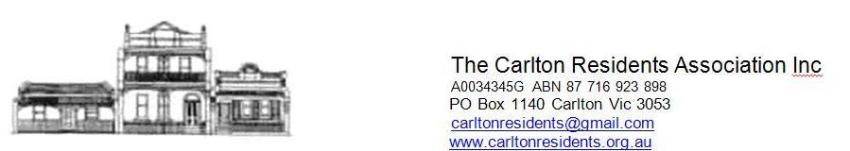

DRAFT 08 02 2023

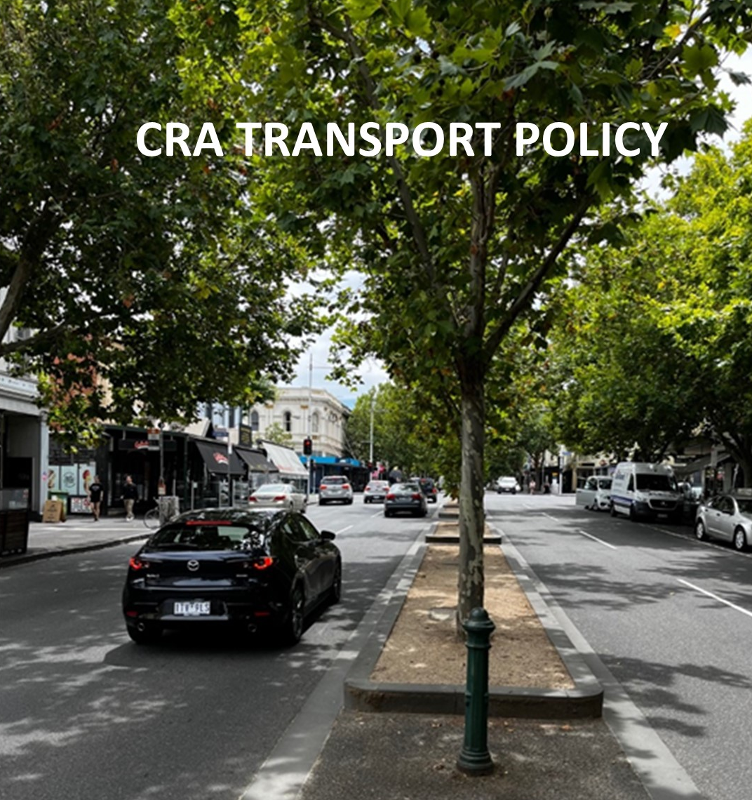
View North along Lygon Street

GENERAL
An important part of the quality and residential amenity of Carlton is the streets and associated traffic including public transport, bicycles and pedestrians.
Over the last 45 years our streets have changed dramatically from wide, treeless bitumen thoroughfares to attractive streets with medians and now mature trees. Through traffic has been reduced by street closures and calming measures such as lane reductions, controlled turns, speed humps. Bicycle and pedestrian paths have been improved and footpaths widened in the commercial areas to allow outdoor eating.
Carlton has had good public transport for a long time and improvements have been made such as the underground rail line now under construction.
There are still areas for improvement and issues of concern that are covered in part in this policy.
The Carlton Residents Association (CRA) has contributed to the City of Melbourne (CoM) transport policies leading to the now adopted ‘Transport Strategy 2030’.
Government policies and committed projects have changed since our previous policy was adopted – ‘CRA Traffic Transport and Parking Policy 2015’.

ROADS
The CRA supports the road hierarchy included in the CoM ‘Transport Strategy 2030’. This includes the following streets being designated as secondary streets-
- Nicholson Street
- Victoria Street
- Queensberry Street
- Grattan Street
- Rathdowne Street
- Lygon Street is included in the CoM strategy but we believe it requires special consideration with a reduced amount of through traffic. Bicycle lanes should not be introduced. Pedestrian areas should be expanded. Noise detector/cameras should be introduced to minimise hooning.
- Lygon Street should have a reduced speed limit, 30 kph and should have the ability for street closures for special events.
- Traffic could be restricted to one lane in each direction with areas for bus stops.
- It is important that Grattan Street should be kept open to through traffic for its full length from Flemington Road to Rathdowne Street.
- It must not be closed to private vehicles at Melbourne University.
- When Grattan Street opens after completion of the underground railway work, Queensberry Street should be reinstated to its former traffic flows before it was modified to cope with the Grattan Street temporary closure.

CRA supports the CoM classification of bypass streets including-
- Princes Street
- Hoddle Street
- Wurunjerie Way
- Lower Yarra Crossing

Local Streets,
- They should have reduced traffic flows and a minimum amount of through traffic. Measures to achieve this include-
- Street blockages and restricted turns
- One lane each way and one way in some cases.
- Slower traffic with lower speed limits.
- The use of streets to include bicycle lanes and parking.
- Increase street planting on kerbsides, median strips and small open area such as those formed by street blockages, roundabouts and other open spaces. Low planting such as grasses and sedges should be introduced. Water absorption areas should be increased.
- Encourage special uses in selected areas such as Parklets for outside dining in commercial areas.

Road Usage-
Footpaths
Use should be restricted to pedestrians, wheelchairs (manual and motorised) and children’s bicycles and scooters when with a parent.
Zebra/Pedestrian Crossings
As for footpaths. No Bicycles, scooters etc.
Bicycle lanes
To be used by bicycles and small engine motor bicycles, scooters etc.
Traffic lanes
For use by all other vehicles including motor bikes, cars trucks and public transport.

SIGNAGE AND TRAFFIC RULES
- Clear signs are required to clarify the above usages and also for safety and legal requirements. For example, signs for cyclists to give way to pedestrians or to turning traffic,
- Road safety rules should be sent regularly to registered vehicle owners and preferably to cyclists and scooter owners. There is a case for compulsory registration of owners of bicycles, scooters etc. which would enable notification of road rules and enforcements and provide a means for monitoring numbers.
- Registration could be free or nominal.
Street Furniture
Street furniture including signs, lights and seating should have coordinated design.

TRAFFIC DEMAND
- Through traffic should be restricted in line with the CoM Strategy.
- Non essential traffic should be minimised including through traffic.
- Essential local traffic should be directed to Secondary or Bypass roads.

PARKING
- Off street parking in private developments should be restricted to encourage other transport uses.
- Reduce on street parking permits for residents and commercial owners.
- Street parking should be maintained where possible after considering other demands for street usage such as pedestrian and bicycle use,
- parklets and green areas.
- Reduce parking that serves the central city/central activity area.
- Encourage car hire spots on streets and in multi residential developments.

BICYCLES

- The CRA supports the introduction of bicycle lanes as outlined in ‘Traffic Strategy 2030’.
- As noted above these lanes could include other uses such as scooters.
- Additional crossings should be provided for pedestrian safety, particularly for children and disabled access.
- Bike parking areas should be provided near retail areas along Lygon Street.
- Encourage Bicycle parking areas in multi residential developments.

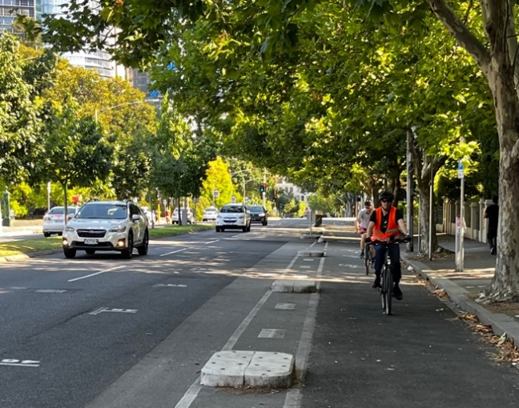
- The CRA supports the introduction of
bicycle lanes as outlined in ‘Traffic Strategy
2030’.
- As noted above these lanes could include
other uses such as scooters.
- Additional crossings should be provided for
pedestrian safety, particularly for children
and disabled access.
- Bike parking areas should be provided near
retail areas along Lygon Street.
- Encourage Bicycle parking areas in multi
residential developments.

PEDESTRIANS
- Streets should include safe pedestrian ways and should provide for enjoyable amenities such as tree and shrub planting, benches, congregation areas etc.
- Clear and safe crossings are required.

PRIVATE CARS
Encourage shared car use. They should be incorporated into larger residential developments.

PUBLIC TRANSPORT
Carlton is well served by public transport.
Rail
The new underground will provide convenient links to the rail network and eventually to the airport.
We support the proposed rail link from Docklands to Clifton Hill.
Trams
Trams in Swanson Street, Lygon Street north, Nicholson Street and Victoria Street provide good access from most residential areas.
Buses
The current coverage is adequate but must be reviewed

FREIGHT AND SERVICE VEHICLES
Provide for those services necessary for the area the area and those that need access through secondary roads.

TAXIS
Support the use of taxis, rental cars and provide standing areas.

ENVIRONMENTAL QUALITY
Pollution
Greenhouse gas emissions should be minimised by methods including-
- An increased use of public transport
- Energy efficient vehicles, electric where possible
- The use of bicycles, motorbikes etc rather than larger vehicles
- for private use and deliveries etc.
- Increase planting to improve environmental quality.

Noise
- Reduce traffic noise.
- Stop hooning by enforcing maximum emissions from the various vehicle types.
HERITAGE ISSUES
Significant heritage features of Carlton streets should be preserved
and protected including-
- Lanes
- Cobbled paving to lanes and street surfaces.
- Basalt kerbs.
- Significant trees.
We appreciate that maintenance works such as relevelling pitches in lanes, will be required and this can be done without destroying the basic heritage significance.

Prepared by-
Carlton Residents Association
Peter Sanders, Antoinette Sagaria, Blair Healey

