CARLTON RESIDENTS ASSOCIATION - MOBILITY POLICY

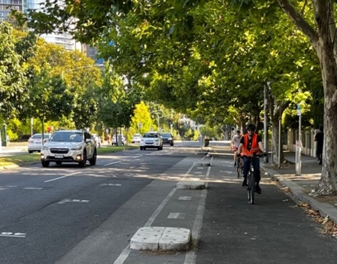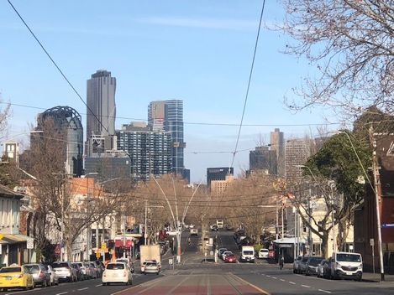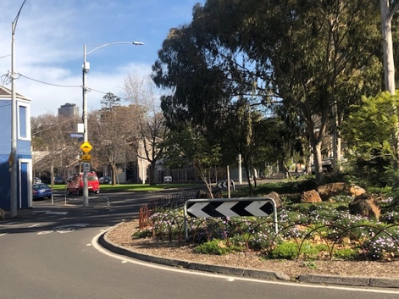

The Carlton Residents Association has renamed its Transport Policy our Mobility Policy to reflect the changing nature of urban transport and how we need to seek sustainable and accessible ways to move around and through our city.

The policy provides a response to how residents, workers and visitors move around the municipality and the importance we place on the liveability and sustainability of our suburb.

In essence, good mobility needs to be safe, reliable, efficient, accessible and sustainable.

In the longer term the objective should be to work toward Sustainable Mobility recognising the need to address mobility and its impact on climate change.

This will require future proofing mobility by moving to EV vehicles, autonomous vehicles, and freeing up road space for public transport, trams and buses, extending footpaths, introducing shareable streets and increasing green spaces by freeing up road space.

Over the last 45 years our streets have changed dramatically from wide, treeless bitumen thoroughfares to attractive streets with medians and now mature trees.

Through traffic has been reduced by street closures and calming measures such as lane reductions, controlled turns, speed humps. bicycle and pedestrian paths have been improved and footpaths widened in the commercial areas to allow outdoor eating. The introduction of parklets has resulted in an improvement in outdoor dining, a reduction and slowing of traffic and improved amenity and safety for pedestrians. It has also encouraged patrons to travel by walking, cycling and public transport.

Carlton has had good public transport for a long time and improvements have been made such as the underground rail line now under construction. Tram stops have been improved to enable those with a disability, children and older persons to have ease of access and safety. We believe that the remaining step-up tram stops should be replaced with those providing for the access required by all.

There are still areas for improvement and issues of concern that are covered in part in this policy.

The Carlton Residents Association (CRA) has contributed to the City of Melbourne (CoM) transport policies leading to the now adopted ‘Transport Strategy 2030’.

Government policies and committed projects have changed since our previous policy was adopted – ‘CRA Traffic Transport and Parking Policy 2015’.

ROADS
The CRA supports the road hierarchy included in the CoM ‘Transport Strategy 2030’. This includes the following streets being designated as secondary streets-

- Nicholson Street
- Victoria Street
- Queensberry Street
- Grattan Street
- Rathdowne Street
- Lygon Street is included in the City of Melbourne strategy but we believe it requires special consideration with a reduced amount of through traffic. Bicycle lanes should not be introduced. Pedestrian areas should be expanded. Noise detector/cameras should be introduced to minimise hooning.
- Lygon Street should have a reduced speed limit, 30 kph and should retain the ability for street closures for special events.
- Traffic could be restricted to one lane in each direction with areas for safe and ease of access at bus stops.
- It is important that Grattan Street should be kept open to through traffic for its full length from Flemington Road to Rathdowne Street.
- Grattan Street must not be closed to private vehicles at Melbourne University.
- When Grattan Street opens after completion of the underground railway work, Queensberry Street should be reinstated to its former traffic flows before it was modified to cope with the Grattan Street temporary closure.

CRA supports the City of Melbourne classification of bypass streets including-
- Princes Street
- Hoddle Street
- Wurundjerie Way
- Lower Yarra Crossing

Local Streets
They should have reduced traffic flows and a minimum amount of through traffic. Measures to achieve this include –
- Street closures and restricted turns
- One lane each way and one way traffic in some case
- Slower traffic with lower speed limits.
- Chicanes and the use of speed humps where vehicles currently are exceeding or are likely to exceed speed limits, especially in residential streets and close to schools and other community facilities.
- Plantings to ensure the amenity and attractiveness of our neighbourhoods
- Traffic calming measures that provide a safe environment for pedestrians and cyclists.
- Using streets to include bicycle lanes and on-street parking.
- Increasing street planting on kerbsides, median strips and small open area such as those formed as a result of street closures, roundabouts and other open spaces.
- Low planting of grasses and hedges to improve the amenity of our neighbourhoods and water sensitive design features introduced to ensure adequate watering
- Maximising pervious surfaces should to ensure maximum water absorption for plants.
- Encouraging special uses in selected areas such as parklets for outside dining in commercial areas.

Road Usage
- Footpaths
Use should be restricted to pedestrians, wheelchairs (manual and motorised) and children’s bicycles and scooters when with a parent.
- Zebra/Pedestrian Crossings
As for footpaths. No Bicycles, scooters etc.
- Bicycle lanes
To be used by bicycles and small engine motor bicycles, scooters etc.
- Traffic lanes
For use by all other vehicles including motor bikes, cars trucks and public transport.
- e-scooters
The trialling of the e-scooter shared scheme by the State Government commenced in 2022 across the cities of Melbourne, Yarra and Port Phillip has raised many questions.

The popular view is that the e-scooter contributes to mobility options but the question is what has been the impact on other mobility options such as walking and cycling?

The CRA believes that at the conclusion of the trial there needs to be a comprehensive review conducted by the City of Melbourne to ensure the views of the community are reflected in the State Government’s decision on the future of the e-scooter shared scheme.

If e-scooters were to be introduced the companies providing the e-scooters need to be held responsible for their use. And the State Government and the City of Melbourne would need to enact laws and a compliance regime to ensure the safety of users, pedestrians and cyclists.

SIGNAGE AND TRAFFIC RULES
- Clear signs are required to clarify the above usages and also for safety and legal requirements. For example, signs for cyclists to give way to pedestrians or to turning traffic,
- Road safety rules should be sent regularly to registered vehicle owners and preferably to cyclists and scooter owners.
- There is a case for compulsory registration of owners of bicycles, scooters etc. which would enable notification of road rules and enforcements and provide a means for monitoring numbers.
- Registration could be free or nominal.

STREET FURNITURE
- Street furniture including signs, lights and seating should have coordinated and simple design and messaging.
- The tendency toward over signage is impacting on our neighbourhoods.
- We believe that signage can sometimes be replaced by well positioned street furniture and bollards.

TRAFFIC DEMAND
- Through traffic should be restricted in line with the City of Melbourne Strategy.
- Non-essential traffic should be minimised including through traffic.
- Essential local traffic should be directed to Secondary or Bypass roads.

PARKING
- Off street parking in private developments should be limited to encourage other transport uses and to reduce the cost of construction and thus the cost of housing.
- Reduce on street parking permits for residents and commercial owners.
- Street parking should be maintained where possible after considering other demands for street usage such as pedestrian and bicycle use, parklets and green areas.
- Reduce parking that serves the central city/central activity area.
- Encourage car hire spots on streets and in multi residential developments.
- Current on street parking restrictions need to be reviewed to ensure residents living close to activity centres are protected from excessive noise and anti-social behaviour and there is consistency in the approach to parking hours across our neighbourhoods.

BICYCLES
- The CRA supports the introduction of bicycle lanes as outlined in ‘Traffic Strategy 2030’.
- As noted above these lanes could include other uses such as scooters.
- Additional crossings should be provided for pedestrian safety, particularly for children and disabled access.
- Bike parking areas should be provided near retail areas along Lygon Street.
- Encourage Bicycle parking areas in multi residential developments.

PEDESTRIANS
- Streets should include safe pedestrian ways and should provide for enjoyable amenities such as tree and shrub planting, benches, congregation areas etc.
- Clear and safe crossings are required.

PRIVATE CARS
Encourage shared car use. They should be incorporated into larger residential developments.

PUBLIC TRANSPORT
Carlton is well served by public transport.

Rail
The new underground will provide convenient links to the rail network and eventually to the airport.
We support the proposed rail link from Docklands to Clifton Hill.

Trams
Trams in Swanson Street, Lygon Street north, Nicholson Street and Victoria Street provide good access from most residential areas.

Buses
The current coverage is adequate but must be reviewed

FREIGHT AND SERVICE VEHICLES
Provide for those services necessary for the area the area and those that need access through secondary roads.

TAXIS
Support the use of taxis, rental cars and provide standing areas.

ENVIRONMENTAL QUALITY

Pollution
Greenhouse gas emissions should be minimised by methods including-
- An increased use of public transport
- Energy efficient vehicles, electric where possible
- The use of bicycles, motorbikes etc rather than larger vehicles for private use and deliveries etc.
- Increase planting to improve environmental quality.

Noise
- Reduce traffic noise.
- Stop hooning by enforcing maximum emissions from the various vehicle types and installing traffic calming and speed reduction measures.

HERITAGE ISSUES
Significant heritage features of Carlton streets should be preserved
and protected including-
- Lanes
- Cobbled paving to lanes and street surfaces.
- Basalt kerbs.
- Significant trees.

We appreciate that maintenance works such as relevelling pitches in lanes, will be required and this can be done without destroying the basic heritage significance nor resulting in impervious surfaces and thus the lack of groundwater.

Prepared by-
Carlton Residents Association

